Slide Deck Introduction to Actively Learn

Page or Click | Speaking Points
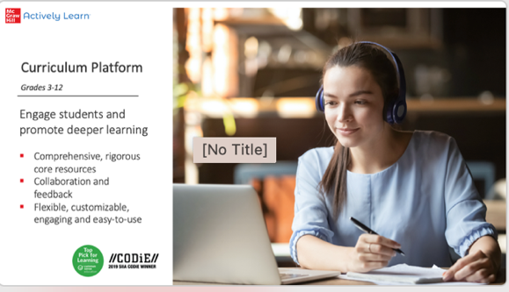 | Use the All Solution Deck or the Solution PPT for Actively Learn.
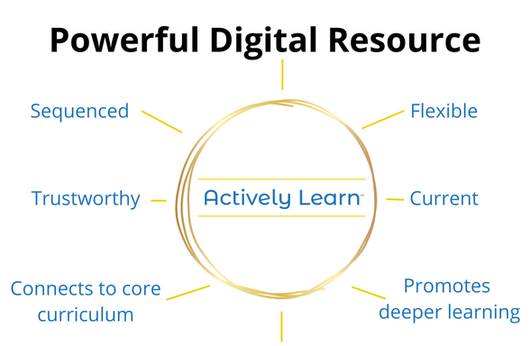 | - Actively Learn is a powerful supplemental tool with sequenced, trustworthy, relevant lessons that engage students, connect meaningfully to core curriculum, and give teachers high flexibility in instruction.  - The district library functions as a curriculum repository, enabling districts to build a flexible  digital curriculum map for all teachers.
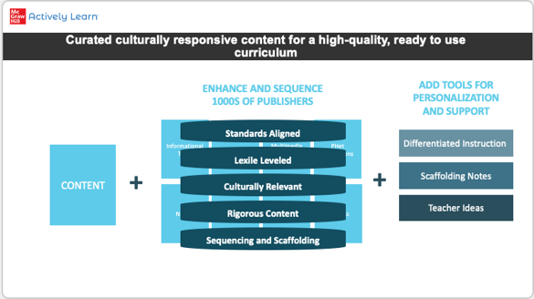 | (You may hide this slide as needed)  Actively Learn’s vast catalog of content allows teachers to select just the right content for their students. They can find content that is  - Aligned to standards for all 50 states  - Aligned to DOK standards  - At the right grade level  - At the right Lexile level  - With built-in accommodations and modifications  Teachers can also choose to personalize these resources for the whole class, small groups, or individuals.
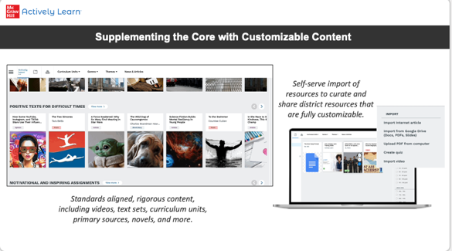 | When using Actively Learn, teachers have the ability to teach with a broad range of diverse, curated resources including high-interest articles, simulations, primary sources and DBQs, short stories, novels, and videos.  One of the things our districts and teachers love is that they can import their own resources and bring them into the platform, so they don’t have to leave anything behind.
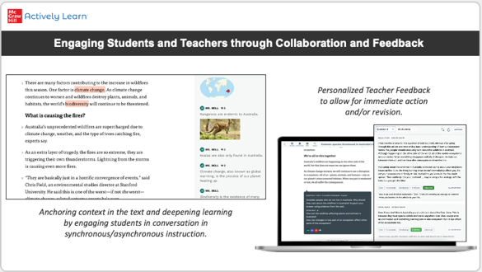 | Actively Learn was designed to prompt student engagement – students can participate in class discussions by annotating and responding to notes in real time, all while thinking and writing about the text they are reading. Teachers love this for whole class instruction, small groups, virtual, and hybrid learning.  Popular features: providing real-time feedback and coaching, allowing students to revise for mastery, and easy grading.
Live Platform Demo
**Should be logged in to Actively Learn Sandbox – select appropriate state, grade level, and content catalog
Screen/ Click | Notes

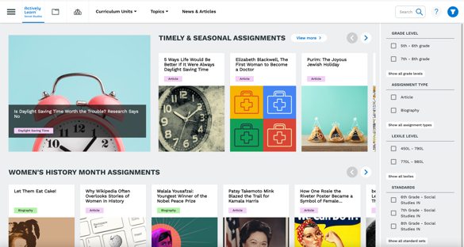 | When teachers sign in, they appear at the landing page for their subject. What they’ll see immediately is a small fraction of the 1000s of resources available in Actively Learn; this page shows just the newest, most timely, and most popular assignments that day. Students do not browse our catalog, so these are all instructional choices teachers can make.  Across the top we can switch catalogs; Actively Learn has ELA, Science, and Social Studies for grades 3-12. All of these subjects feature engaging resources with instruction aligned to state standards and DOK.  The options across the top (Curriculum units, Topics, Genres, News & Articles) allow you to search for and organize content.  Along the side you can filter by grade band, assignment type, Lexile level, or standards.  Click on a standard and then populate the standard set. Select one to show that teachers can search by standard for resources that are aligned to that standard. (I recommend selecting this in advance to make sure an appropriate number of resources populate for the standard.)
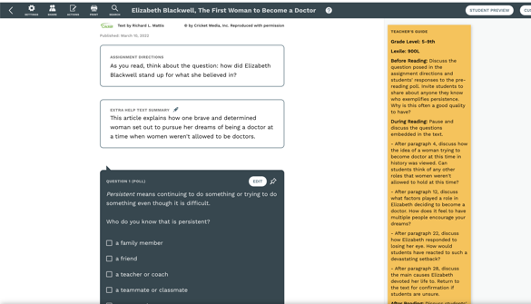 | Open an assignment and talk through the standard layers in Actively Learn.  - At the very top we source and date the text for full transparency.  - At right is a Teacher’s Guide with notes; before, during, and after reading activities; and related extension assignments so that teachers don’t have to go into any lesson cold.  - We provide assignment directions.  - We start many assignments with a poll to get students engaged in the topic. After students answer, they see all the answers populate anonymously in real time, revealing classmates’ different perspectives.  - Scroll to show the built-in, standards-aligned questions and annotations in the margins, automatically featuring the teacher’s name.  - We end assignments with open-ended questions so students have to think deeply and demonstrate understanding.
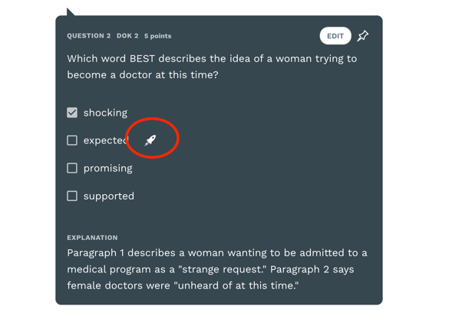 | Actively Learn offers pre-made accommodations and modifications as scaffolds, known as Extra Help, so teachers don’t have to spend their time making them in the platform.  Teachers can turn on these Extra Help scaffolds in the roster, and can keep them on for the entire time the student is enrolled in the class. They can also be turned off if needed. These are very helpful for students with English Language Development services, Special Education services, or students in the MTSS / RTI process.  We offer 4 of these accommodations and modifications:  - Text Summary at the beginning to build background and establish a context for reading (Note: students don’t see the words “Extra Help”; only the teacher does)  - Additional margin notes and images  - We remove a distractor from the auto-graded, check-for-understanding questions  - We add additional thought guidance on the open-ended questions.
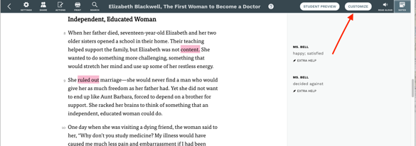 | One reason teachers love Actively Learn is that they can customize all of the existing instruction to make sure it meets their instructional needs.  Click Customize at the top right.
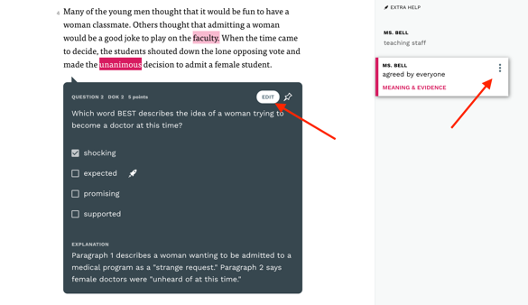 | After clicking Customize, teachers can edit existing instruction:  They can click on the three dots in margin notes to edit instruction, add or delete images or media, adjust for Extra Help, etc.  They can click Edit on any of the existing questions to edit question types, standards, add media, and move questions to make sure the questions meet their needs.
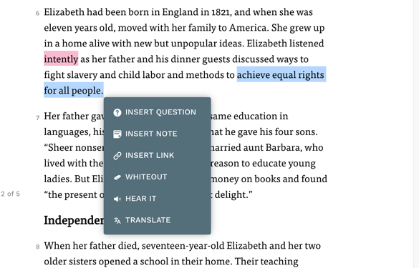  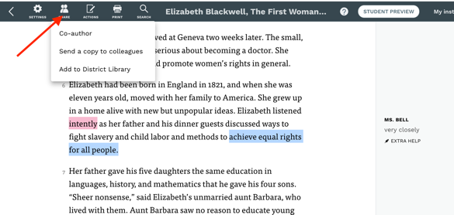 | In addition to editing existing instruction, teachers can use their mouse to customize assignments in Actively Learn, whether they are videos, primary sources, short stories, or articles; teachers can make sure their instructional goals are met.  Teachers can add questions with all five question types, insert notes or links, etc.  Once teachers have customized the instruction the way they want, they can click the Share button in the top left to share the lesson with colleagues or add to the District Library. This means that teachers who share common planning groups don’t have to duplicate work.
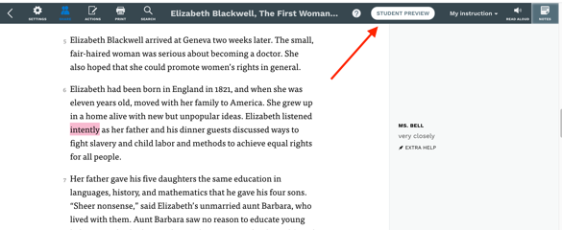 | To show the student experience, click “Student Preview” in the top right corner.
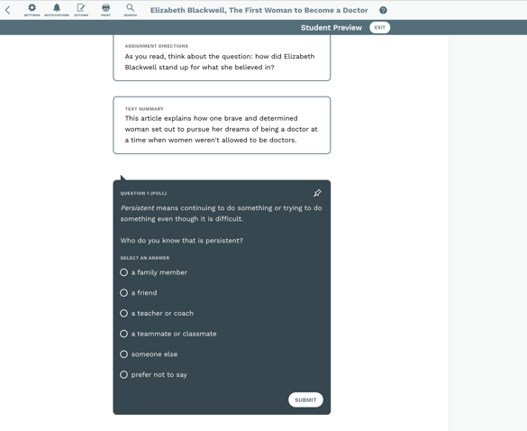 | In the Student Experience, our default is to gate text to promote close reading.  We ask students to focus on a small section of text at a time, and they must engage with a question that references the immediate preceding text to move on and unlock the next section of text.  Like many features in Actively Learn, this is a default setting that can be customized.
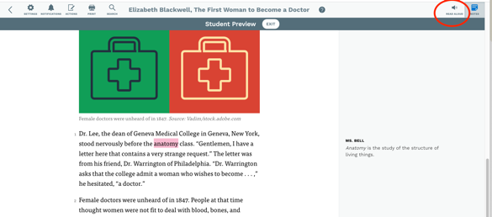 | Students can access support in three places in Actively Learn.  In the top right students can turn on full audio support from where they are in the text to the next question.
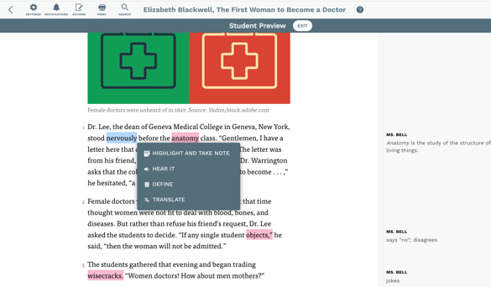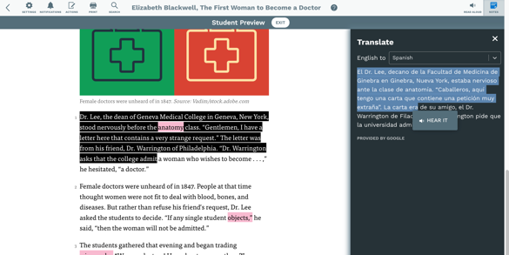 | Students’ support scaffolds at point of use allow them to do the following:  - Students can highlight any one word to define from an embedded dictionary to provide vocabulary support in context. (We track this so that teachers can see which words students are looking up.)  - Students can add their own annotations in the margin or respond to annotations already there from the teacher or classmates.  - Students can select “Hear it” for audio support in smaller sections of text.  - Students can select a section of text to translate into over 100 languages.  - Highlight the translated text to show authentic TTS support in our top 10 most frequently translated languages.
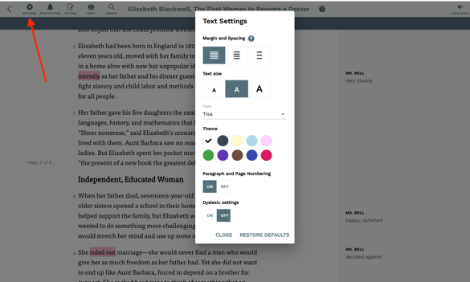 | In the top left students can select the “Settings” gear wheel.  This opens their text settings. Students can adjust their margins and spacing, text size, and font, which are helpful for students with visual impairments.  Students can also select background colors.  Turn on “Dyslexic settings” – these are research-based best practices to help students with dyslexia engage in an electronic platform.

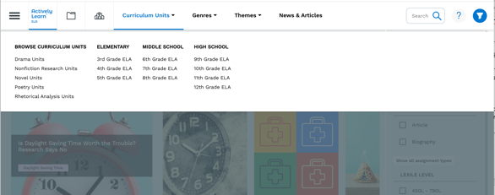  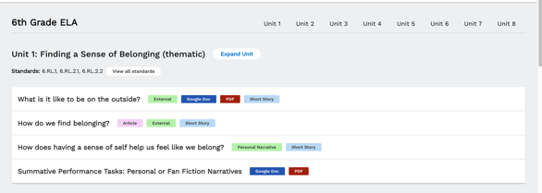 | Go back to the landing page:  In any subject (depending on what the customer needs), show the curriculum units, at the top.  These are examples of a scope and sequence; many of our partners pick and choose the pieces from these suggested maps that match their curriculum maps.  Additionally, those with McGraw Hill’s Inspire Science and U.S. History core curriculum will find Actively Learn core supplements that connect to each chapter.  In the curriculum units, each color represents a different type of resource, showcasing the breadth of resources available in Actively Learn.
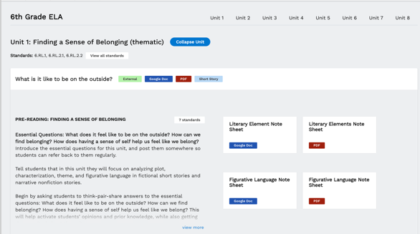 | When you expand the curriculum unit, you have access to the Teachers Edition for that suggested unit.  You can see the aligned standards, all resources and notes, graphic organizers, and assignments in Actively Learn. You can assign from these sections.  In ELA and Social Studies, there are also summative assessments in each unit. In Science, we show the NGSS alignments covered in each unit.
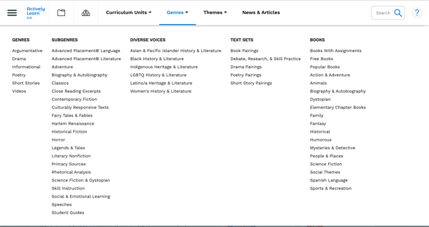  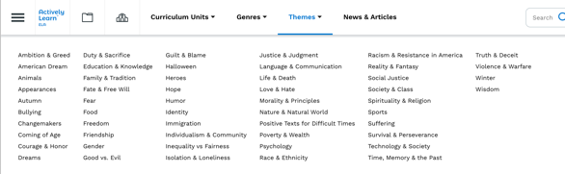 | ELA TOPICS  - In the ELA Catalog there are two “topics” pages – resources are sorted by Genre and by Themes.  - Searching on the Themes page will return multi-genre text sets all tied to the selected theme.  - From Genres, show all the ways to access texts.  - Highlights include poetry for all grades, the AP topics pages for high schools, and rhetorical analysis instructional resources.
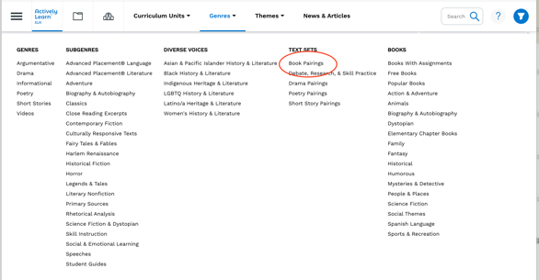  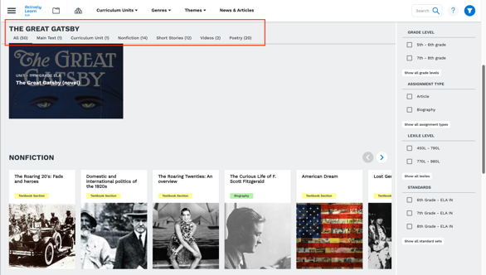 | Text Sets feature curated collections of texts so that teachers don’t have to spend time looking for related resources. Actively Learn’s collections are especially useful for teachers who use StudySync’s core curriculum and need related fiction and nonfiction texts to help students develop deeper content knowledge and make important connections.  Click on “Book Pairings” and then scroll through these popular titles, or show the “Story Story Pairings.”  One popular example is “The Great Gatsby.” This text set has a main text, in this case the full novel – all built out with instruction and scaffolds, a curriculum unit, and related resources a teacher might need when teaching this text.  These related resources are categorized at the top of each text set.  We do offer full-length novels in Actively Learn.  - Titles in the public domain are available as “Free Books.”  - We work with major publishing companies to offer full-length ebook novels on our platform.  - These can be rented per title/student, or we offer an unlimited novel subscription for $8/student/year in Actively Learn. The publishers view these as consumables so they are one per student, and we do pay royalties to the publishing companies.
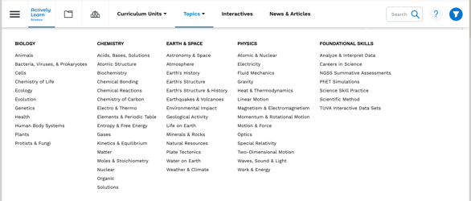 | SCIENCE TOPICS  In Actively Learn Science, our resources are designed to be searched from the search bar or the topics page. We know different states and districts teach science courses in different ways, so we want science teachers to have access to materials that meet their needs.  Highlights of the Science Catalog:  - PhET simulations with engaging side-by-side AL instruction  - TUVA interactive data sets (student-inquiry led)  - NGSS Assessments designed to measure all 3 cross-cutting dimensions of the performance expectations  - Curriculum units and assessments that are phenomenon- driven.  - Student skill practice and data analysis assignments  - Videos with instruction
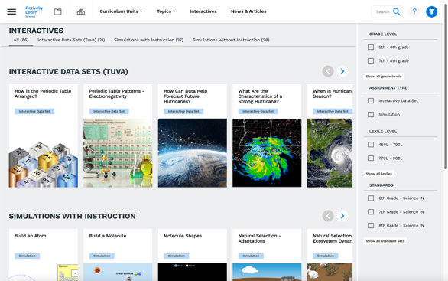 | Click on “Interactives” to more easily show the PhET simulations and TUVA Interactive Data sets  - PhET simulations have been recoded to work across all platforms and are mobile-optimized.  - Simulations with instruction are aligned to state standards lead students through instruction.  - Simulations without instruction can be customized with teachers’ questions and notes to guide students.  - TUVA data sets lead students through data-driven inquiry.
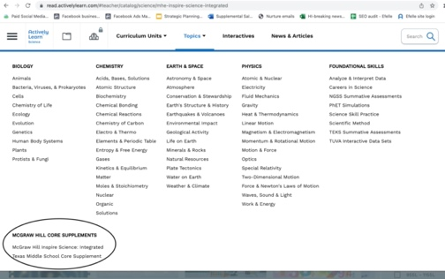 | From the top of the science page, hover over “Topics,” and click on McGraw Hill Core Supplements at the bottom. These connect to McGraw Hill’s Inspire Science curriculum.  - Show 6th grade, 7th grade, and 8th grade supplements that connect to Inspire Science (Units 1-4 for each grade)  - You can also show the Featured Assignments and the Careers in Science section.  - For Texas, look below the McGraw Hill Core Supplements section to find the Texas Middle School Core Supplements.
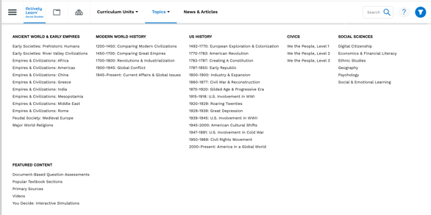 | SOCIAL STUDIES TOPICS  Similar to Science, our social studies resources are designed to be searched from the search bar or the topics page. We know different states and districts teach social studies courses in different ways, so we want teachers to have access to materials that meet their needs.  Highlights of the Social Studies Catalog  - Aligned to standards for all 50 states  - Primary sources, Document Based Questions (DBQs), videos  - The large Social Sciences section features popular resources on digital citizenship, economics and financial literacy, ethnic studies, geography, psychology, and SEL  - DBQ Assessments ask students to work with several documents and answer a detailed writing prompt
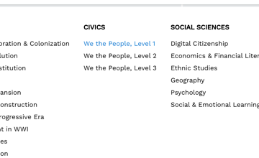  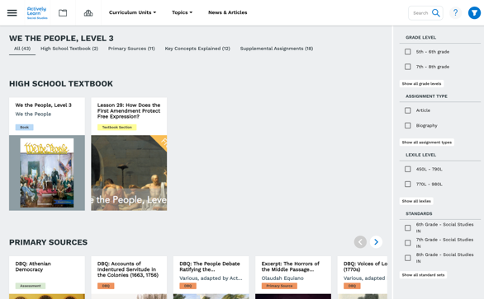 | Civics  Actively Learn has a long partnership with the Center for Civic Education and is pleased to offer the full digital text of the We the People textbook series built out with instruction in Actively Learn.  - Level 1 is the elementary text.  - Level 2 is the middle school text.  - Level 3 is the high school text.  - There are related resources curated to these topics.  - Teachers can customize the instruction and questions and control how much of the text they assign to students.
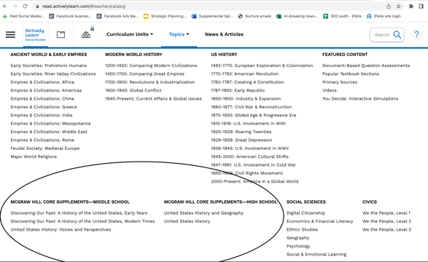 | From the top of the social studies page, hover over “Topics,” and click on McGraw Hill Core Supplements for Middle School and for High School at the bottom. These connect to McGraw Hill’s U.S. History curriculum.  - For middle school, show Discovering our Past: U.S. History Early Years, U.S. History Modern Times, and U.S. History Voices and Perspectives  - For high school, show U.S. History and Geography  - If you hover over the “Chapter Supplements” and “Chapter Topics” for each, you’ll see texts to support students at a higher reading level who can explore the topics further. You’ll also see texts to support students at a lower reading level.
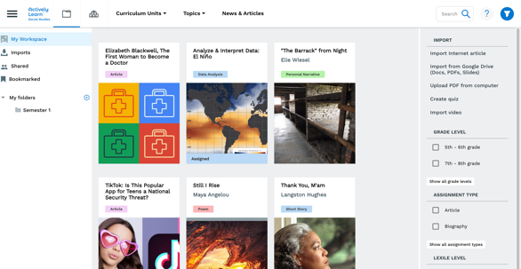 | In My Workspace and Imports  Teachers can see any assignment they have customized, that they have bookmarked for later, and that has been shared with them.  They can create common planning folders or folders for storing their resources.  Teachers can import Google docs and slides, PDFs, videos, or internet articles. I recommend using an AP News article if showing the import feature.  Check this article for detailed directions on how to import https://help.activelylearn.com/hc/en-us/articles/115000274393-Add-your-own-content
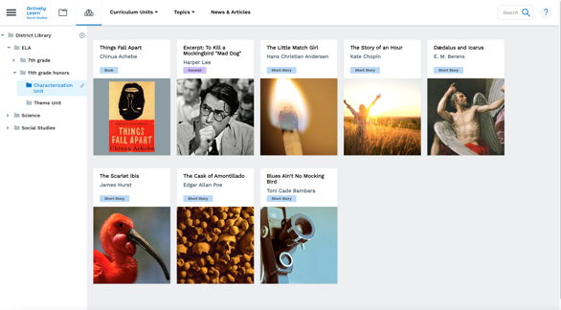 | District Library  The School/District Library is a curriculum repository that allows schools and districts to create digital curriculum maps so all teachers have equitable access to selected resources.
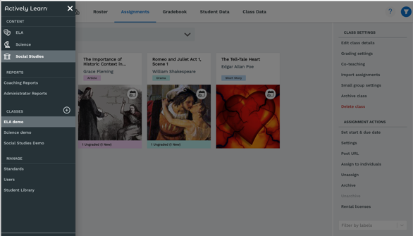 | From the main menu, navigate to a class, then select an assignment.  In an assignment, show the data and grading features.  - Show how to customize the class settings and add co-teachers here.  - Show the gradebook and student/class data pages here.  Start at 6:27 in this video for guidance on the assignment data and gradebook options: https://vimeo.com/591314955
From the main menu, navigate to the Administrator and Coaching Reports section to show these features.

For guidance on these reports, watch this 4-minute video:
https://vimeo.com/592872032

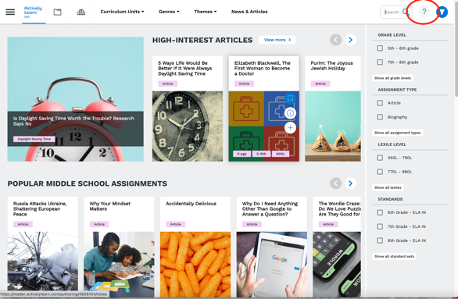  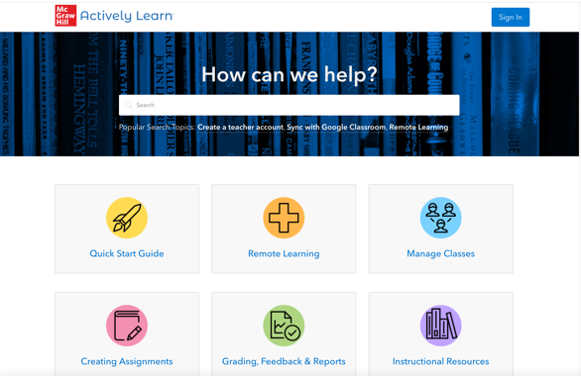 | To close, show the Actively Learn Help Center.  From any Actively Learn page, click the “?” in the top right.  This will open the Help Center or allow you to send a message. Our live, knowledgeable support staff will respond to your message. We receive many customer compliments on our support service.  You can also use our Help Center to find answers on your own. You can use any of the categories below or search for a topic.  Search results have videos and step-by-step directions, so any questions will be answered.

